**On Sale Notification for Pebble**

Project Proposal

­­­

By

**Mr. Teetach Phaopanus 542115024**

**Mr. Achirawee Kuntano 542115070**

Department of Software Engineering

College of Arts, Media and Technology

Chiang Mai University

Project Advisor

________________________

**Mr.Kittitouch Suteeca**

|  |  |  |  |  |  |  |  |  |
| --- | --- | --- | --- | --- | --- | --- | --- | --- |
| **Document Name** | **Version** | **Status** | **Date** | **Viewable** | **Reviewer** | | **Responsible** | |
| **Documents** | | | | | | | | |
| On Sale Notification- Project Proposal_V.0.1.docx | - Adjust Project Name  - Adjust Abstract  - Add Chapter2  - Technology Review  - Development Tool Review  - Add Chapter4  - Project Plan  -Add Chapter5  - References | Draft | 5-02-2014 | TP, AK, KS | | TP, AK | | TP, AK |
| On Sale Notification- Project Proposal_V.0.2.docx | - Add Chapter2  - Business Review  - Business tools  - Add Chapter5  - References  - Change font and font size  - Add Chapter 1  - Background & introduction | Draft | 16-02-2014 | TP, AK, KS | | TP, AK | | TP, AK |
| On Sale Notification- Project Proposal_V.0.3.docx | - Add Chapter 4  - Schedule & Milestone review  - Change Aim of project  - Add Chapter 2  - Add Software Review.  - Add Chapter 3  - Quality Standard  - Adjust Chapter5  - References | Draft | 26-02-2014 | TP, AK, KS | | TP, AK | | TP, AK |
| On Sale Notification- Project Proposal_V.1.0.docx | Change Font size | Released | 04-03-2014 | TP, AK, KS | | TP, AK | | TP, AK |
| On Sale Notification- Project Proposal_V.1.1.docx | - Add Technology Review | Released | 25-03-2014 | TP, AK, KS | | TP, AK | | TP, AK |

**Document History**

**\*KS = Kittitouch Suteeca**

**\*AK = Achirawee Kuntano**

**\*TP = Teetach Phaopanus**

# Abstract

# Today the shops have created many technic promotions on sale product. So many promotions are arriving. That make customers can not follow all sale products promotion and the customers cannot remember or make a note all on sale product that they interesting. It must be invented a new application that shops can create promotion on sale products which is can trust. The application that has ability to remind or use to review new on sale products. This problem is invented a new software which is can manage about sale products .The seller independent to create shops online that show all sale products. The customer can bookmark sale product that they interesting. The register system can guarantee the all of shop in the application is not fake. Product grouping system to help customer find sale product they need. The vibration on smart watch helps to remind customer when they stay near on sale product place. The application software develop to defend from the customer who easy to forget buying sale product on their list .This problem almost cause on buyer .The buyer so must happy on shopping then this is make them forgot the main point. These impair the chance of sale product.

**Table of contents**

Abstract 3

Chapter One | Introduction and Background 5

Chapter Two | Literature Review 6

2.2 Business Tools and Software Review 7

Software Review 7

Software Description 8

Technology Review 9

2. MySQL Server 15

Alternative Tool 17

The selection of this tool 17

Chapter Three | Quality Standard 20

3.1 ISO29110 for Very Small Entity (VSE) 20

3.1.1 Project Management process (PM process) 20

3.1.2 Software Implementation process (SI process) 21

Chapter Four | Project Plan 22

4.1 Motivation 22

4.2 Aims and Objectives 23

4.3 Deliverables and Limits 24

Chapter Five | References 32

**Chapter One | Introduction and Background**

Many shops have sale product, in everyday has many Promotional Products On Sale. That is good for Customers to choices cheap product. But the problem also occurs with the customer part which is occur when customers can not follow all of promotional products on sale before expire. So they exploring sale product by them self or receive a brochure to home. Some customers try to find a way to buy sale products and some take a note on sale product that they interesting. But it still crashes, because went shopping at Most customers will not pay attention to their sale product list until forgot to buy it. And the shops also need to disseminate their advertise as fast as they can do.

Nowadays a new technology such as smart phone which is has an application that can recode and notification. This function is base to build much application and the one of that is the application that uses to find sale product shops .This application is not Independence to management of the store, from the shops. And notification system that cannot remind customers if they not pick phone to look. With these problems, our group decides to create the software which is can solve all problems that occur. By creating the application on smart phone and on website for give customer to search and bookmark sale product .The shops can use a website to independent build promotional products on sale and has administrator verify promotion to guarantee for customers. When customers stay near on sale product place. The vibration on smart watch will help to remind customer every time.

# Chapter Two | Literature Review

**2.1 Business Review**

Overview

On sale notification is a Pebble, website and android application that develop by HTML5, PHP, CSS3, Java script, Pebble SDK, and Android SDK. It is an application that created for helping people who want to shop but forgot the shop that they want to buy. This application will solve that problem by notice via pebble and smart phone.

Target

The main target of “on sale notification” is to provide many shop that sell discount product and many categories of product to help user select product. This project also notice user when they going near the shop that they booking.

Benefit

* User can remember the product which they booking when they live near that shop.
* User can view many promotions by using this application.

## 2.2 Business Tools and Software Review

## Software Review

1. Wong Nai

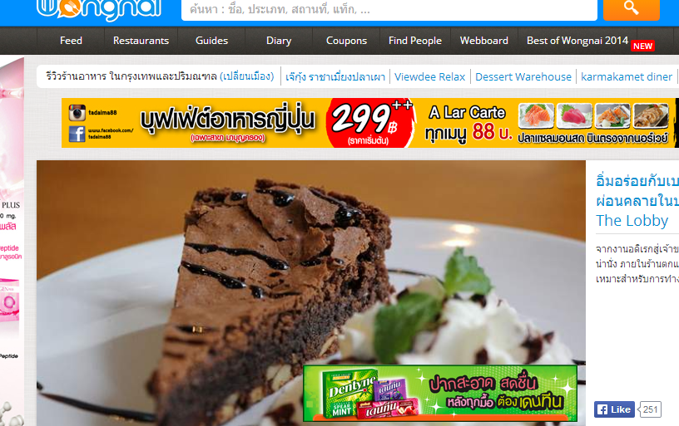

Figure 1 Wong Nai Website

## Software Description

Wong Nai application is website that reviews some food station. This website also uses to find the food station. It has many members about 800,000 people who use it. These website consist of many data of food shop such as Name, location and detail of their shop.

**Pros**

-One app all function such as can take photo, comment, browse ,bookmark ,random ,shard and so on.

-Advertisement positioned is not cluttered.

-Support national language such as English language.

- The information of shop is clear and reliable.

**Cons**

**-**When stay in the area which no internet signal, the application cannot use in some main feature.

-First use the application need to register to the system.

-The application has many feature and deep thread navigation that make new user confused.

## Technology Review

1. Google Map API



Figure 2 Google map logo

**Technology Detail**

Google map is the application of Google to identified location of some place that user stay or shop. This is an application programing interface of Google. It is a free service of Google. It also provides the function for import Google map into our application.

**Alternative technology**

* Bing Map

**The selection of this technology**

* This API provides every feature that support our application.
* Implement this API by copy the code that they provide its.
* Clearly to identified the location.

2. CSS3



Figure 3 CSS3 logo

**Technology Detail**

CSS3 or Cascading Style Sheet3 is the language for define the form of website. It use for decorate the website such as beautiful color, good interface or define the margin and border. It also works with HTML5.

**The selection of this technology**

* Control the display of our website on every page as well.

3. HTML 5



Figure 4 HTML 5 logo

**Technology Detail**

HTML is stand for “Hypertext Markup Language”. It is the pattern for developing website. About HTML 5, it has more function than the old HTML. HTML 5 has support many platform such as desktop PC, mobile and tablet.

**Alternative technology**

* HTML 4 or older version.
* Adobe Flash.

**The selection of this technology**

* Pattern for develop our website.

4. PHP



Figure 5 PHP logo

**Technology Detail**

PHP language use to develop website and display into HTML form. It is the language that developer can easy to understand. PHP is part for process, calculate and get value

**Alternative technology**

- ASP

- JSP

- HTML

- Ruby

- Python

**The selection of this technology**

* PHP is open source. It will have a lot of tutorials and reference on the

website.

5. Java script



Figure 6 JavaScript logo

**Technology Detail**

JavaScript is another language that we use for creating website because JavaScript can operate with HTML page. We can add the JavaScript programing web page to user for the various calculation results or transmission the data.

**Alternative technology**

* JSX

**The selection of this technology**

* Work as many platforms.
* Has a lot of library that provide for upgrade website.

**Tool Review**

1. Eclipse



Figure 7 Eclipse logo

**Development tool Detail**

Eclipse is free and open source software. It is provide the programming support to the Java, C and etc. It also provides library or many features that support to developer. Eclipse can work with Android SDK for develop the mobile application.

**Alternative technology**

* IntelliJ IDEA
* Net Bean

**The selection of this technology**

* Eclipse is a free tool for develop software.
* It can work with Android SDK.
* Eclipse can develop software in every language.

## 2. MySQL Server



Figure 8 MySQL logo

**Development tool description**

MySQL is a relational database management system via using SQL language for command the system. It is free software and support many development tools. It work only on database such as create the tale, edit the data from database, delete the database and etc. It can communicate with PHP, C#, Java and etc.

**Alternative technology**

- Microsoft Access

- SQLite

**The selection of this technology**

* Standard program for manage the database.
* High performance.

3. Dream weaver



Figure 9 Adobe Dreamweaver logo

**Development tool description**

Dreamweaver is program for create website developing by Adobe. Dreamweaver has function for create, picture, table, form, video and etc. It provides the page for creating HTML file, PHP file or ASP file.

## Alternative Tool

* Notepad++
* Coda2
* Sublime Text 2
* TextMate
* EditPlus

## The selection of this tool

* Fast to developing website.
* High performance for Editor.
* Provide a function for make developer easy to coding.

4. Pebble SDK

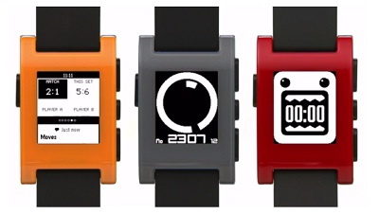

Figure 10 Pebble smart watch picture

**Development tool Detail**

Pebble SDK is an application programing interface for developing Pebble smart watch. This SDK provides every function that important for create Pebble application.

**The selection of this technology**

* Tool for developing Pebble Application.

5. Android SDK



Figure 11 Android logo

**Development tool Detail**

Android SDK is stand for Android Software Development Kit. It is a program for programmer to develop his application in Android form. Android SDK provide emulator of phone for simulate working on phone.

**The selection of this technology**

* This is tool use to develop an Android application.

# 

## 

6. Dynamic Publishing Technique

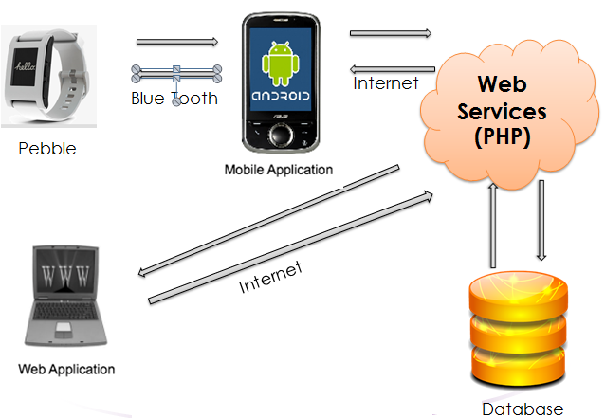

Figure 12 Dynamic Publishing Technique picture

**Development tool Detail**

Dynamic Publishing Technique is technique that imports the data from database for display on Web page.

**The selection of this technology**

* When user change, add or delete the information that would appear on a Web Page changes associated automatically.

# Chapter Three | Quality Standard

## 3.1 ISO29110 for Very Small Entity (VSE)

ISO 29110 is the ISO concept to emphasize the growth of small and medium industries. Including a new one for a chance to compete on the guideline development Outsourcing. VSE stand for Very Small Entity is small group of enterprise or organize that having up to 25 people.

ISO/IEC 29110, targeted by audience, has been developed to improve product and/or service quality, and process performance. This ISO focus on Project Management process and Software Implementation process.

### Project Management process (PM process)

PM process uses the Customer’s Statement of Work to elaborate the Project Plan. The PM project assessment and control tasks compare the project progress against the Project Plan and actions are taken to eliminate deviations or incorporate changes to the Project Plan. The PM project closure activity delivers the Software Configuration, produced by SI, and gets the Customer’s acceptance to formalize the end of the project. A Project Repository is established to save the work products and to control its versions during the project. It consists of 4 activities.**Activities**

* Project Planning
* Project Plan Execution
* Project Assessment and Control
* Project Closure

### Software Implementation process (SI process)

The purpose of the Software Implementation process is the systematic performance of the analysis, design, construction, integration and tests activities for new or modified software products according to the specified requirements.

This part of ISO/IEC 29110 is intended to be used by the VSE to establish processes to implement any development approach or methodology including, e.g., agile, evolutionary, incremental, test driven development, etc. based on the VSE organization or project needs. It consists of 6 activities.

**Activities**

* Software Implementation Initiation
* Software Requirement Analysis
* Software Architecture and Detailed Design
* Software Construction
* Software Integration and Tests
* Product Delivery

We use basic profile for develop our project , basic-Target VSEs is developing only one project at a time.

# Chapter Four | Project Plan

## Motivation

Most of The people nowadays give more precedence to the sale products. The shops try to make promotion on sale to attract customers. The customers that interested on the sale products will just remember it or more than that, they just physically take a quick note. Those are the simple methods that everyone has been used before. However, the problem is when they actually go to buy those sale products, they just forgot because sometimes they enjoy for the other things too much. Plus, some people have different styles of shopping. When they see any sale products, they will compare the price from the Brochures to save more money. On the other hand, some customer might not be able to find the shops that are on the promotion, or they might have no idea when the promotion will get expired. Due to those situations, it is possible that they will lose their opportunity to buy cheaper products.

Therefore, we will use a modern technology such as smart phone application which has many useful capabilities. For our system, the user can use it to take a note or to record something. Another interesting technology is the smart watch which can use to send some instant messages and use as the warner by vibrating. Those abilities can be applied as a reminder function for our system.

Due to this reason, we think there should be a system helping the sellers create their own shop and make promotions on their own. They will directly get the reliability from customers. The customers also be able be in a part of shops’ reliability by giving each of them ratings. Moreover, the customers can use the bookmark function from their smart phone to record information, and notification function from the smart watch to notify the customer immediately. This application helps the users in convenience of their shopping activities and would help them save their own money too.

## Aims and Objectives

**4.2.1 Aims**

The aim of this project is to develop a system to mobile application on android, Smart Watch Pebble and website application. This will provide a system to manage about shops on sale products, which is provided customer to view or bookmark the sale products their interesting. Moreover, there will be the vibration at the user’s smart watch when the user walks near the shop as reminder. As a result, both customers and sellers will be able to fully efficiency and comfortable to do their jobs from this system.

**4.2.2 Objectives**

- Provide interface that easy for user to understand and use application.

- Provide categories for separate type of on sale product.

- Provide alarm of reminding on sale products that user bookmark and it will notice user when they stays near sale product place.

## - Alternative way to help amnesia user for remember their interests.

## - Alternative way to view the map on Google map.

## 4.3 Deliverables and Limits

### Deliverables

1) 1st progress

- Web Page of program

- Registration and login system.

- Administrator system.

- Social network sharing.

- Searching product system.

- Member & Non-Member system.

- Showing Product page and Home page.

- Selling product.

2) 2nd progress

- Android application

- Notification alert in Android.

- Make relation with website.

- Google map with all location of On sale application.

3) 3rd progress

- Pebble application

- Connecting between Pebble and Android phone.

4) The document and other material

- Proposal

- Project plan

- Quality plan

- Software requirement specification

- Traceability record

- Software design document

- Testing document

* Test plan
* Unit test report
* System Test report

- 1 CD-ROM stores all source code; relate file, all documents and poster files in PDF format.

- 1 project poster

### Limits

* The application requires Internet connection to execute.
* The application can run only on android more than 2.0 for smart phone because Pebble SDK supports an Android more than 2.0 version.
* The application only work between Pebble and Android phone.
* Member can upload their product only on web browser.
* The application contains information only in Chiang Mai.

**4.4 Schedule & Milestones**

**Notation:**

Feature #1: Consists of user registration page, homepage and report page.

Feature #2: Consists of Admin system, Member & Non-Member system.

Feature #3: Consists of selling product.

Feature #4: Consists of social network system and searching product system.

Feature #5: Consists of Google map with all location of On sale application & notification alert in Android.

Feature #6: Consists of make relation with website.

Feature #7: Consists of connecting between Pebble and Android phone.

**Schedule Plan:**

Proposal phase: Create proposal document.

Progress I: Create Development plan, Quality plan, SRS, SDD and some part of Test document. Start creates feature# 1, 2, 3, 4 of system.

Progress II: Create feature# 5 and 6 of the system, overall of the system should be higher than 70%. Continue on Test document.

Progress ShowPro: Create feature# 7 of the system and integrate all features. Overall of the system should be complete or nearly. Continue on Test document.

Final Progress: Integrate and review all document. Make sure all system and document are complete.

# Chapter Five | References

[1] Adobe Dreamweaver CS6. Available from

<http://www.adobe.com/products/dreamweaver.html>

[2] CSS. Available from <http://en.wikipedia.org/wiki/Cascading_Style_Sheets>

[3] Google Map. Available from

<http://maps.google.com/help/maps/getmaps/advanced-options.html>

[4] HTML. Available from <http://en.wikipedia.org/wiki/HTML>

[5] HTML5. Available from <http://www.w3schools.com/html/html5_intro.asp>

[6] MySQL. Available from

<http://en.wikipedia.org/wiki/MySQL>

[7] CSS3. Available from

[Craig Cook](http://www.amazon.com/s/ref=ntt_athr_dp_sr_1?_encoding=UTF8&field-author=Craig%20Cook&search-alias=digital-text&sort=relevancerank) and [Jason Garber](http://www.amazon.com/s/ref=ntt_athr_dp_sr_2?_encoding=UTF8&field-author=Jason%20Garber&search-alias=digital-text&sort=relevancerank), Foundation HTML5 with CSS3 (New York: friendsofED, 2012), pp. 17-36

[8] Chrome Available form;

<https://www.google.com/intl/en/chrome/browser/beta.html>

[9] Android SDK Available from

<http://developer.android.com/sdk/index.html?utm_source=weibolife>

[10] Pebble SDK Available form

<https://getpebble.com/>

[11] Pebble SDK Available form [https://www.eclipse.org](https://www.eclipse.org/)

[12] PHP form www.w3schools.com/php

[13] Wong Nai form http://www.wongnai.com

All of Reference Accessed on 04 March 2013